Following My Brother’s Pencil
By Jivard
As a little boy, I didn’t yet know what was best in this world. I believed only what I saw, and what surrounded me became my truth.
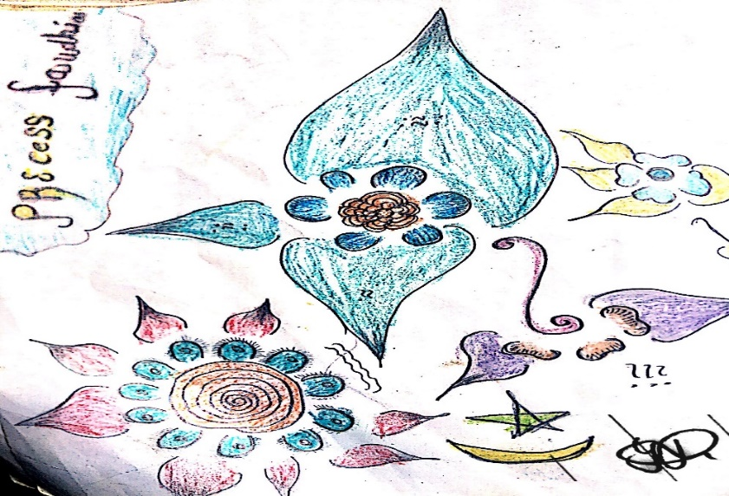
It was a Saturday morning, the kind of day when the week ahead quietly begins to take shape. I sat at the table, watching my brother’s hand glide across the paper. His sketches seemed impossible — so clear, so alive, that I imagined the objects stepping out of the page to greet their drawn reflections.
My brother loved drawing animals and footballers. His pencil moved with a rhythm I couldn’t look away from. To be like him, I drew every chance I got. Newspapers became my treasure maps; I hunted for the football pages, memorizing faces and names — Suárez, Neymar, Herrera, Ronaldinho. Soon, I could recognize every great player at a glance, and classmates came to me for answers. I was proud, but never satisfied.
Because no matter how much I copied, I couldn’t catch him. He had something unique — a way of bending his wrist, sketching lightly first, creating what he called a “sketch plan.” It was as if he was mapping the journey before the pencil truly began. I watched silently, absorbing his strength, never noticing his weaknesses.
He would bend his wrist first, almost lazily, as if drawing didn’t matter. But then his pencil began to move — tracing faint lines, mapping invisible paths across the paper. He called it his “sketch plan.” To me, it was magic: a secret blueprint only he could see.
I watched in silence, amazed at how much care he gave to every stroke, how patient he was with the process. That style still lives in me today. Whenever I pick up a pencil, I picture his hand beside mine, guiding me. It feels as though my brother is still there, whispering through the rhythm of the lines, reminding me to give time, to give care, to let the drawing breathe before it becomes real.

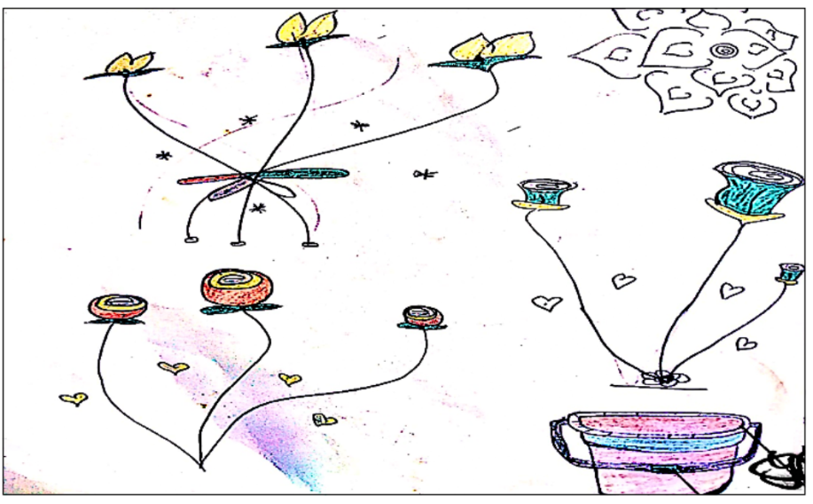
That habit stayed with me. Even today, when I draw, I picture his hand beside mine. His style became my compass, guiding me through the world of art. And as I grew, I found new “brothers” — artists whose pencils danced in ways I could only admire. Yet the principle remained the same: sit close, observe, and learn.
Day by day, I improved. Praise from others brought me closer to him, but I knew he was always one step ahead, always discovering something new. That uniqueness is what I love most. My pencil still follows the direction of my brother’s pencil — and in that pursuit, I find
my pencil always follows the direction of my brother until today. day to day I find myself improved and improved, getting more appreciations makes me even more near to my brother. He is unique, he has something new. Which is what I love
And so, every time I hold a pencil, I feel my brother’s presence guiding me. His sketch plan became more than a technique — it became a lesson in patience, care, and vision. What began as a boy copying lines has grown into a lifelong journey of creativity.
I may never fully catch him, but that’s the beauty of it. His uniqueness pushes me forward, reminding me that art is not about winning or losing, but about following the lines that inspire us. My pencil still follows his — and in that pursuit, I have found my own path, my own voice, and my own world. His name is Jonah, I am his young one, Jivard. I could give you players drawing, they seem far to reach, I will find a time to sit with my brother and draw again.

